~~Personal Insurance, Inc.~~

Shelly Cashman Access 2019 | Module 8: SAM Project 1a



~~Macros, Navigation Forms, Control Layouts~~

# ~~GETTING STARTED~~

* ~~Open the file~~ **~~SC_AC19_8a_~~*~~FirstLastName~~*~~_1.accdb~~**~~, available for download from the SAM website.~~
* ~~Save the file as~~ **~~SC_AC19_8a_~~*~~FirstLastName~~*~~_2.accdb~~** ~~by changing the “1” to a “2”.~~

~~If you do not see the .accdb file extension in the Save As dialog box, do not type it. The program will add the file extension for you automatically.~~

* ~~Open the~~ **~~_GradingInfoTable~~** ~~table and ensure that your first and last name is displayed as the first record in the table. If the table does not contain your name, delete the file and download a new copy from the SAM website.~~
* ~~PROJECT STEPS~~

1. ~~Personal Insurance, Inc. is a national company that insures homeowners and renters. As a regional manager, you and your colleagues need to be able to access forms and reports by simply clicking tabs and buttons, rather than using the Navigation Pane.   
     
   Open the~~ *~~Preview Umbrella Policy List~~* ~~macro in Design View. Change the View argument to~~ **~~Print Preview~~**~~. Save the change to the macro, then close the~~ *~~Preview Umbrella Policy List~~* ~~macro.~~
2. ~~The~~ *~~Open Customer Address List~~* ~~macro contains an error. Complete the following tasks to correct the macro:~~
   1. ~~Open the~~ *~~Open Customer Address List~~* ~~macro in Design View.~~
   2. ~~Click the~~ **~~Single Step~~** ~~button.~~
   3. ~~Run the macro.~~
   4. ~~Correct the error. (~~*~~Hint:~~* ~~The macro should open the~~ *~~Customer Address List~~* ~~in Print Preview mode.)~~
   5. ~~Click the~~ **~~Single-Step~~** ~~button again to deselect it.  
        
      Save and close the~~ *~~Open Customer Address List~~* ~~macro~~*~~.~~*
3. ~~Create a new macro with two submacros by following the directions below:~~
   1. ~~When the Macro Design window opens, display the Action Catalog.~~
   2. ~~Add the first submacro to the macro, using~~ **~~Open Homeowners Table~~** ~~as the name for the submacro.~~
   3. ~~In the first submacro, use the Open Table action to open the~~ *~~Homeowners~~* ~~table in Datasheet View and in Edit data mode.~~
   4. ~~Add a second submacro to the macro, using~~ **~~Open Renters Table~~** ~~as the name for the macro.~~
   5. ~~In the second submacro, use the Open Table action to open the~~ *~~Renters~~* ~~table in Datasheet View and in Edit data mode.~~
   6. ~~Save the macro using~~ **~~OpenTables~~** ~~as the macro name.  
        
      Confirm that your macro matches Figure 1, and then close the macro.~~

* ~~Figure 1: OpenTables Macro~~

~~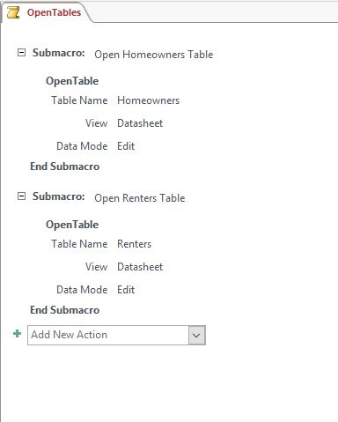~~

1. ~~Open the~~ *~~Claims~~* ~~table in Datasheet View, and then create a data macro for the table by completing the following tasks:~~
   1. ~~Click the~~ **~~Before Change~~** ~~button on the Table Tools tab.~~
   2. ~~Create the macro shown in Figure 2.  
        
      Save and close the macro and then save and close the~~ *~~Claims~~* ~~table.~~

* ~~Figure 2: DataMacro for a Before Change Event~~

~~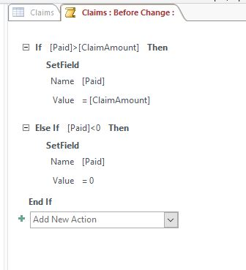~~

1. ~~Create a Datasheet form based on the~~ *~~ClaimsRep~~* ~~table, and then save the form using the default name~~ **~~ClaimsRep~~** ~~as the form name. Close the form.~~
2. ~~Create a Navigation form for the database with the following options:~~
   1. ~~Use the~~ **~~Horizontal Tabs~~** ~~layout.~~
   2. ~~Add the~~ *~~Customers~~*~~,~~ *~~Homeowners~~*~~, and~~ *~~Renters~~* ~~Datasheet forms to the Navigation form in that order.~~
   3. ~~Change the title (in the Form Header) using~~ **~~Basic Navigation Form~~** ~~as the new title.~~
   4. ~~Save the navigation form using~~ **~~Basic Navigation Form~~** ~~as the form name.  
        
      Confirm that your form matches Figure 3. Save and close the~~ *~~Basic Navigation Form~~*~~.~~

* ~~Figure 3: Basic Navigation Form in Form View~~

~~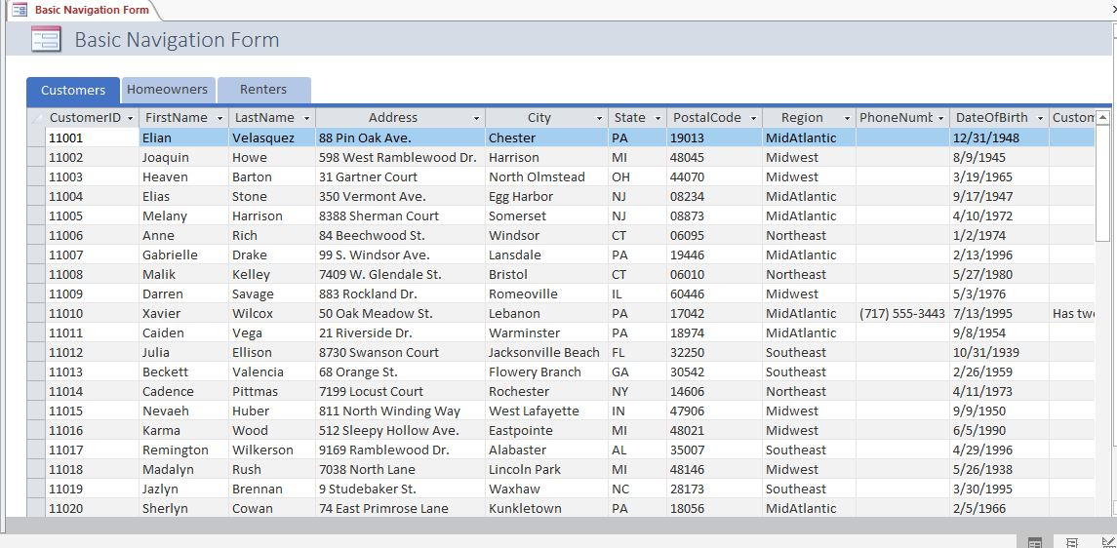~~

1. ~~Open the~~ *~~Customers~~* ~~form in Datasheet View, and then complete the following tasks to create a UI macro for the form:~~
   1. ~~Select the~~ *~~CustomerID~~* ~~column.~~
   2. ~~Click the~~ **~~Property Sheet~~** ~~button.~~
   3. ~~Click the~~ **~~Build~~** ~~Button for the On Click Event, and then select~~ **~~Macro Builder~~**~~.~~
   4. ~~Create a macro that opens the~~ *~~Customer Master Form~~* ~~when a user selects a value in the~~ *~~CustomerID~~* ~~column. The macro actions are shown in Figure 4.  
        
      Save and close the macro, and then save and close the form.~~

* ~~Figure 4: UI Macro Associated with On Click Event in the Customers Form~~

~~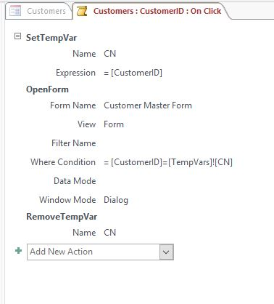~~

1. ~~Open the~~ *~~Main Menu Navigation Form~~* ~~in Layout View, and then complete the following tasks:~~
   1. ~~Add the~~ *~~Forms List~~* ~~form to the~~ *~~Main Menu Navigation Form~~* ~~as the last horizontal tab.~~
   2. ~~Rename the Forms List tab using~~ **~~Master Forms~~** ~~as the new tab name.~~
   3. ~~Move the Customers tab so that it appears first in the list.  
        
      Confirm that the form matches Figure 5, and then save and close the form.~~

* ~~Figure 5: Main Menu Navigation Form in Layout View~~

~~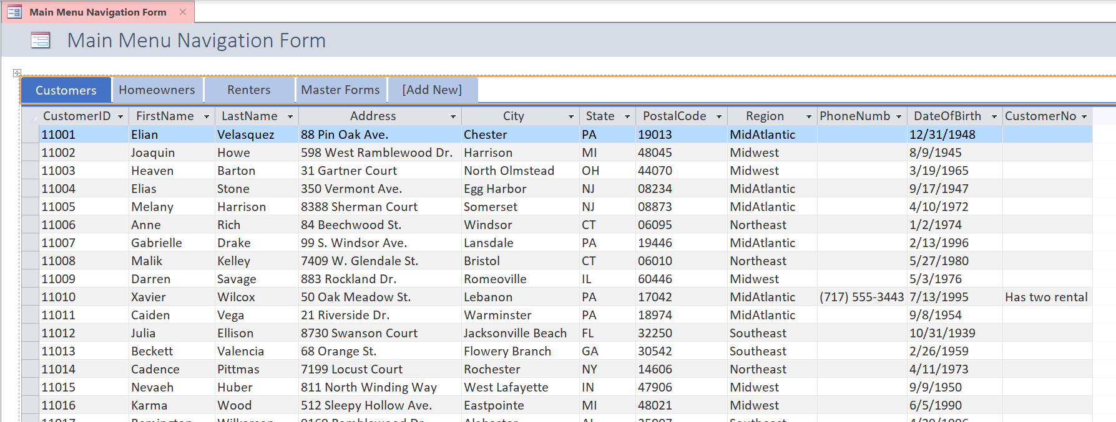~~

1. ~~Open the~~ *~~Open Master Forms~~* ~~form in Design View, and then add a command button to the form in the approximate position shown in Figure 6. Use the Command Button wizard to create the command button while incorporating the following options:~~
   1. ~~Select~~ **~~Miscellaneous~~** ~~as the category and~~ **~~Run Macro~~** ~~as the action.~~
   2. ~~Select~~ **~~Open Forms.Open Renters Master Form~~** ~~as the macro.~~
   3. ~~Select the~~ **~~Text~~** ~~option, and then enter~~ **~~Open Renters Master Form~~** ~~as the text.~~
   4. ~~Use~~ **~~Open_Renters_Master_Form~~** ~~as the name for the command button.  
        
      Save the changes to the form, but do not close it.~~
2. ~~With the~~ *~~Open Master Forms~~* ~~form still open in Design View, complete the following tasks:~~
   1. ~~Select the three buttons on the form, and then use the Size/Space menu to adjust the size to~~ **~~To Widest~~**~~.~~
   2. ~~Use the Size/Space menu to adjust the spacing of the button controls to~~ **~~Equal Vertical~~**~~.~~
   3. ~~Align the buttons to the~~ **~~Left~~**~~.  
        
      Confirm that your form matches Figure 6, and then save and close the~~ *~~Open Master Forms~~* ~~form.~~

* ~~Figure 6: Open Master Forms Form in Design View~~

~~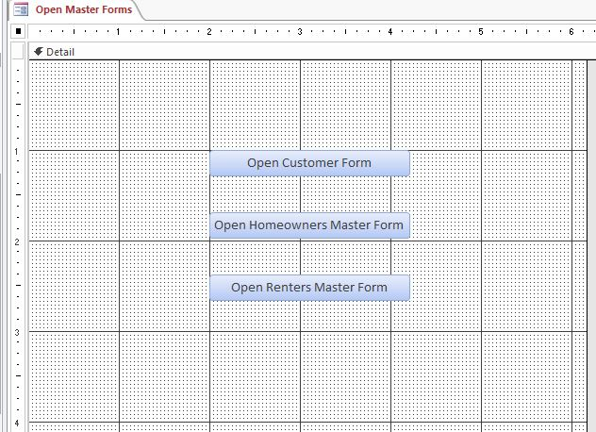~~

1. ~~Open the~~ *~~ClaimsRep Layout Form~~* ~~in Layout View, and then modify the form to match Figure 7 by completing the following tasks:~~
   1. ~~Select the cell containing the value for the~~ *~~FirstName~~* ~~field, and then split the cell~~ **~~horizontally~~**~~.~~
   2. ~~Delete the~~ *~~LastName~~* ~~label.~~
   3. ~~Move the cell containing the value for the~~ *~~LastName~~* ~~field to the position shown in Figure 7 (to the right of the FirstName field in the cell created in Step 11a).~~
   4. ~~Change the~~ *~~FirstName~~* ~~label to~~ **~~Rep Name~~** ~~(including the space), as shown in Figure 7.~~
   5. ~~Move the~~ *~~HireDate~~* ~~label and~~ *~~HireDate~~* ~~field value to the position shown in Figure 7.~~
   6. ~~Select the control layout for the form and then change the control margins to~~ **~~Medium~~** ~~and the control padding to~~ **~~Narrow~~**~~.  
        
      Save and close the~~ *~~ClaimsRep Layout Form~~*~~.~~

* ~~Figure 7: ClaimsRep Layout Form in Layout View~~

~~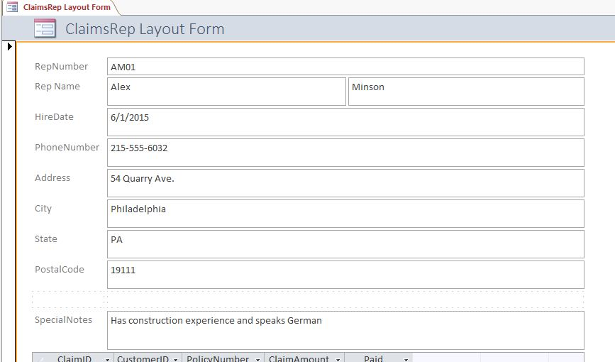~~

1. ~~Open the~~ *~~ClaimsRep and Claims Tabular Report~~* ~~in Layout View. Select the control layout, and then change the report layout to~~ **~~Stacked~~** ~~as shown in Figure 8. Save the change to the report and close it.~~

* ~~Figure 8: ClaimsRep and Claims Tabular Report in Layout View~~

~~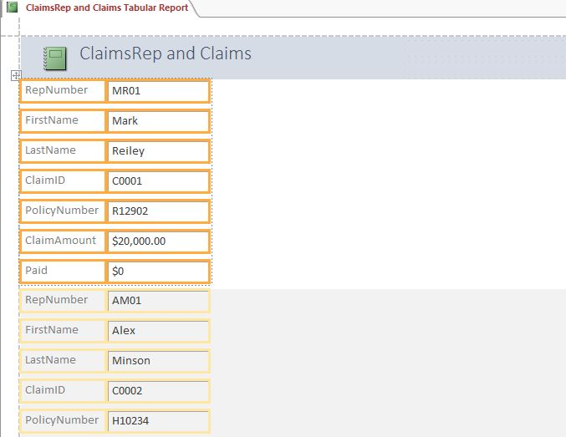~~

Save and close any open objects in your database. Compact and repair your database, close it, and then exit Access. Follow the directions on the SAM website to submit your completed project.